sudo apt update , sudo apt install python , sudo apt install python3-nmap

1. Develop nmap scanning codes using python in Kali linux as shown in the figure below

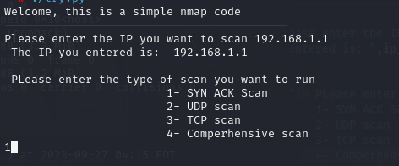

***Answer: 1- Code script***

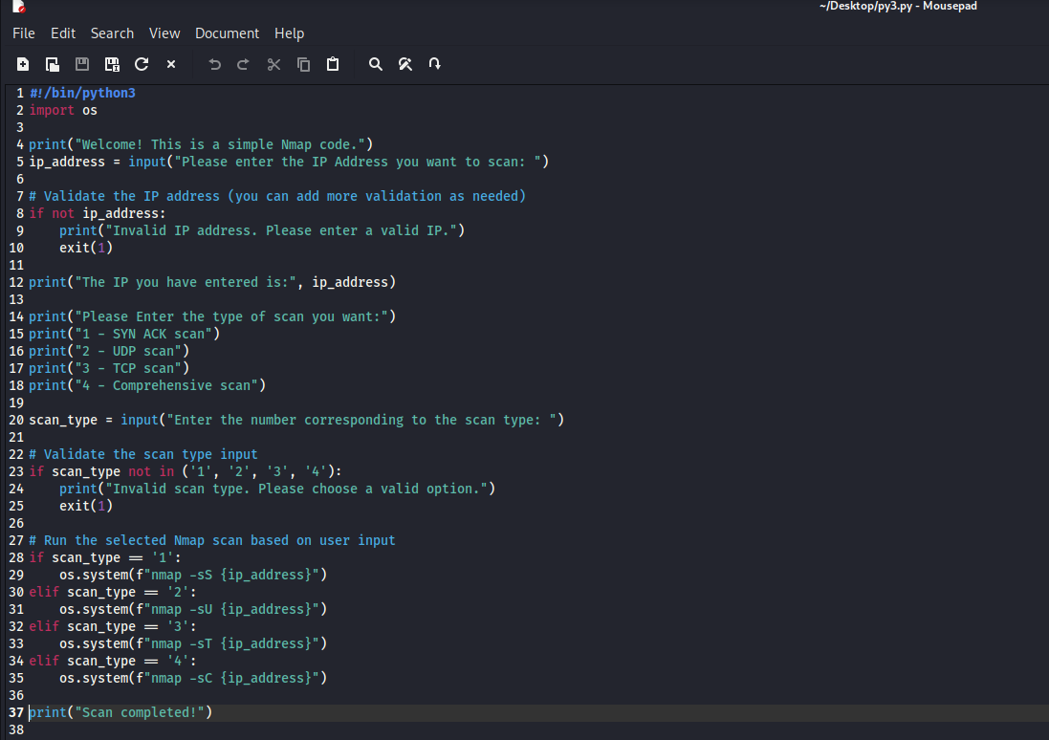

***Answer: 2- Action Performed***

